**ISA Simulator for APEX**

CS 520 – Computer Architecture and Organization

**Team Members:**

1. **Akshay Gulhane**

**B Number:** B00642001

**Email:** [agulhan1@binghamton.edu](mailto:agulhan1@binghamton.edu)

1. **Sarang Sawant**

**B-Number:** B00663811

Email: [ssawant5@binghamton.edu](mailto:ssawant5@binghamton.edu)

**Contents:**

|  |  |  |
| --- | --- | --- |
| **S. No.** | **Topic** | **Page No.** |
| 1 | Introduction to APEX Pipeline | 1 |
| 2 | Code Walk – through | 2 |
| 3 | Screenshots of Input Files |  |

APEX Simulator:

APEX (A Pipeline EXample) is a in-order pipeline.

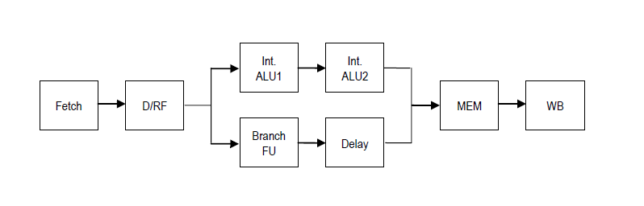

Fig 1. APEX Pipeline Design

**Instruction Set:**

1. Register-to-register instructions: ADD, SUB, MOVC, MUL, AND, OR, EX-OR

ADD → ADD <dest> <src1> <src2>

SUB → SUB <dest> <src1> <src2>

MUL → MUL <dest> <src1> <src2>

AND → AND <dest> <src1> <src2>

MOVC → MOVC <dest> <src1> <src2>

OR → OR <dest> <src1> <src2>

EX-OR → EX-OR <dest> <src1> <src2>

1. BZ, BNZ, JUMP, BAL, HALT

BZ → BZ #literal (checks the z(zero) flag (slide 4 Page 213))

BNZ → BNZ #literal (goes to the instruction at #literal (Slide 2 Page 66))

JUMP → JUMP <src> @#literal (Page 2 of Project Description)

BAL →

HALT → Stops execution

1. LOAD, STORE

LOAD → LOAD <dest> <src1> <literal>

STORE → STORE <src1> <src2> <literal>